MTD Details tab:

When looking at last 3 months, the months are not shown chronologically when comparing last three months across a year end (I.e., Dec appears as most recent month in the graphs/tables) which looks misleading: **[done]**

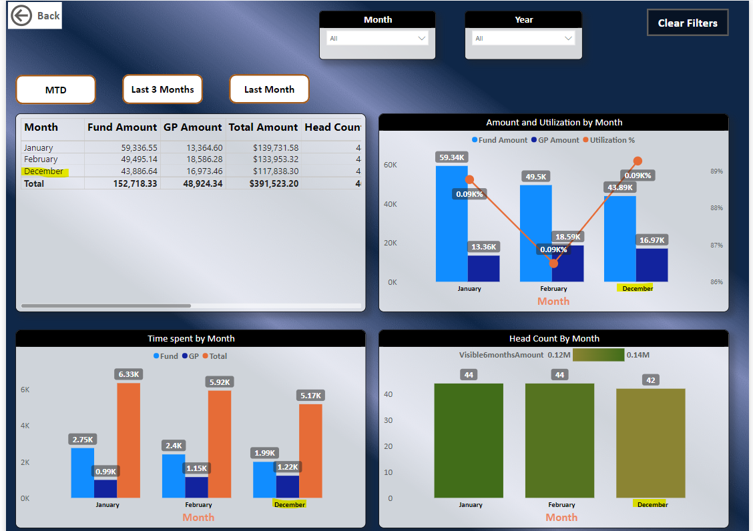

**Year wise attrition table: (In progress)**

Data is useful, is there a way to drill down by platform?

**Utilization data tab: (In progress)**

**It** **would be useful to show month/year in titles and year in the Quarter buttons**. It’s confusing when we’re crossing years for example I can’t easily tell if this report is showing Q1 2024 data or Q1 2023 data. Minor but also February is spelled wrong.

-Prior comment regarding Fund Hours + Downtime = 100% is not addressed. Fund Hours also include GP time so I think the use of the word “Fund” here is misleading as that is both Fund and GP hours that are non-downtime related.

Fund+GP+Downtime =100%

* Replace all – “Fund Hours % Month” by new column which will contains pure “Fund” Hours.
* Hemanth – will work on last 3 months data.

**Is there a way to toggle the Central team resources in/out of the Cost Center views? For example, when filtering for Energy there are a lot of Central Team resources showing. (Need clearity by Kundan)**

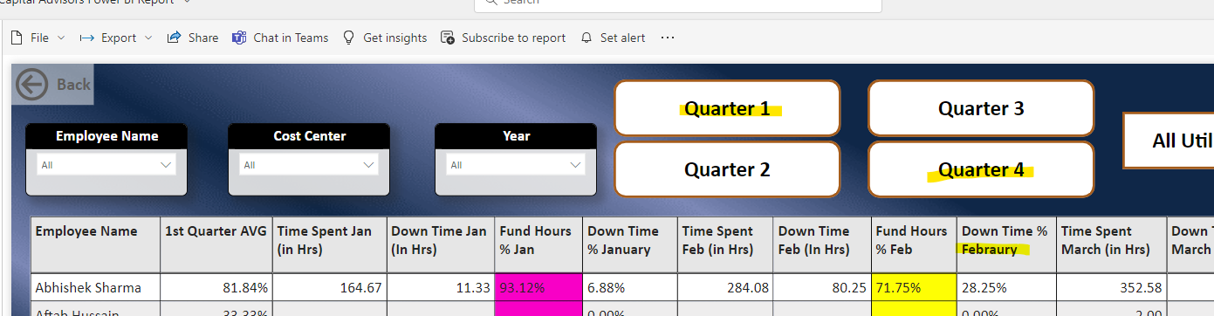

**Billing data tab: (Addressed)**

Is there a way to filter by the Note column? For example, in the current Excel version of the report I will look for GP charges not related to downtime for example to make sure I agree with the GP classification.

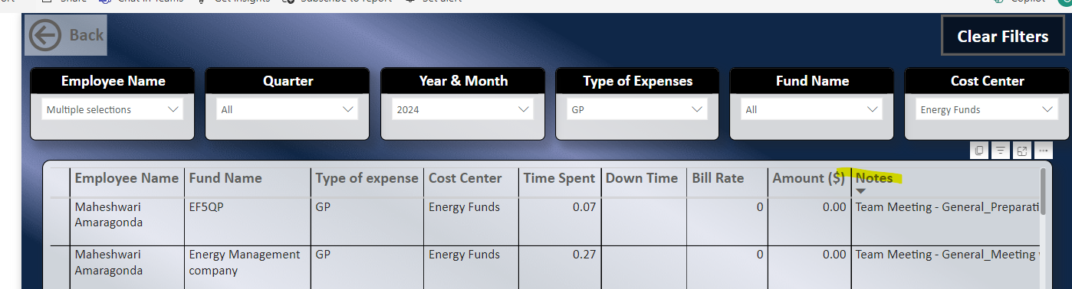

**KPI tab: (Addressed)**

**This is currently setup by “GP Classification”** but perhaps this should be setup by Cost Center instead? For example, Energy Funds is a setup as a single cost center and that’s how we manage the team but in this table it is split into KPIEF Funds and KAEF Funds separately so I’d need to manually add those bars together.

**Employee Over Time Details: (Addressed)**

**Is there a way to filter this report by Cost Center?** **Currently there aren’t any filters except for name/time period** and would be helpful to be able to quickly view overtime by Cost Center in the aggregate.